# Assembly

1. Peel paper from base plate and motor mounts.
2. Identify top of base plate.
   1. Note the orientation of the holes circled below.

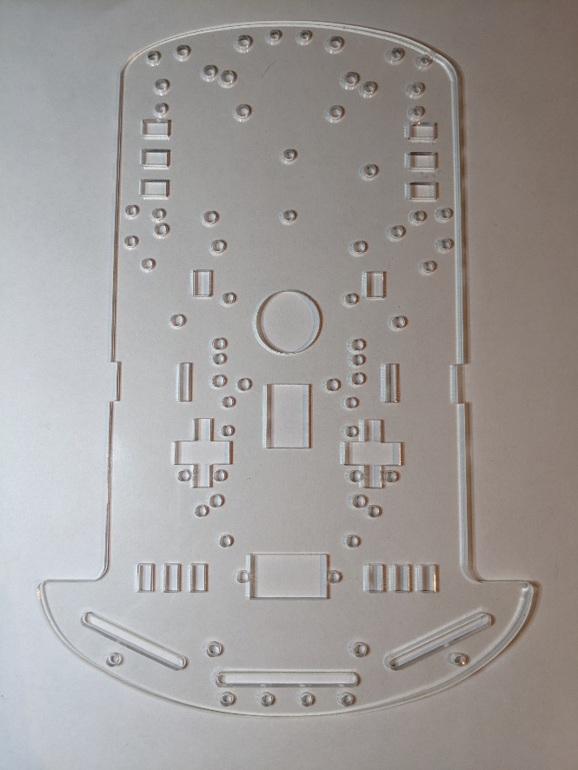

1. Identify motors (2), motor mounts (4), long bolts (4), and nuts (4).

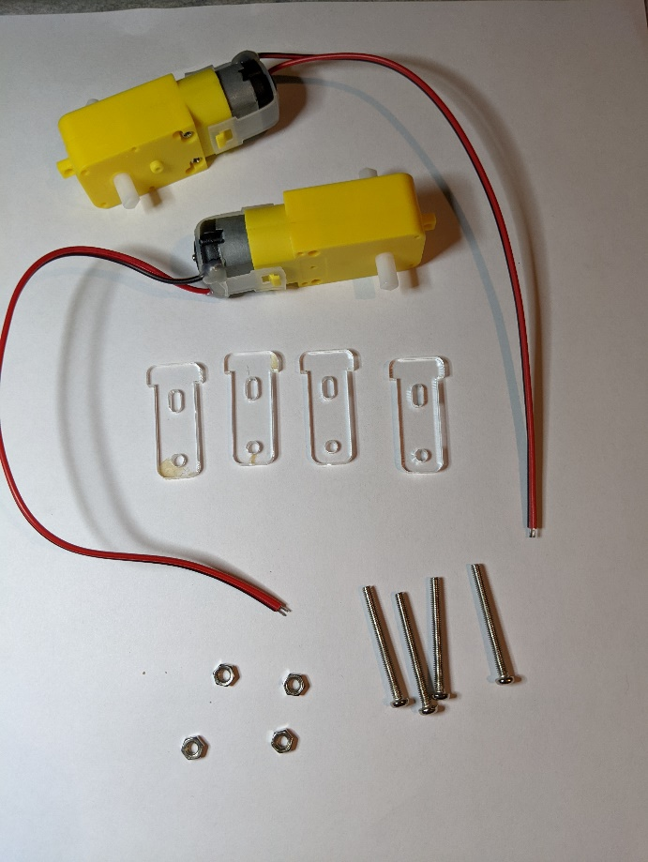

1. Insert one motor mount from the top of the base plate through the slot.
2. Line the holes in a motor up with the holes on the motor mount.
   1. The motor goes on the bottom of the base plate.
   2. The wires should be towards the narrow end of the base plate and should be towards the center.
3. Place a second motor mount along the outside of the motor. It will fit in the cutout along the edge of the base plate.
4. Insert 2 long bolts through both motor mounts and the motor.
5. Attach a nut to the bolt and tighten.
6. Repeat for the second motor.

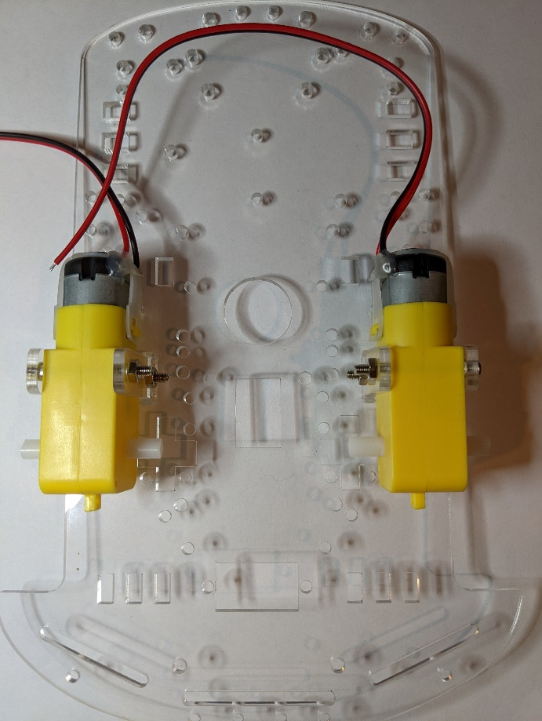

1. Connect the 2 rotary encoder disks to the motors on the interior shafts.

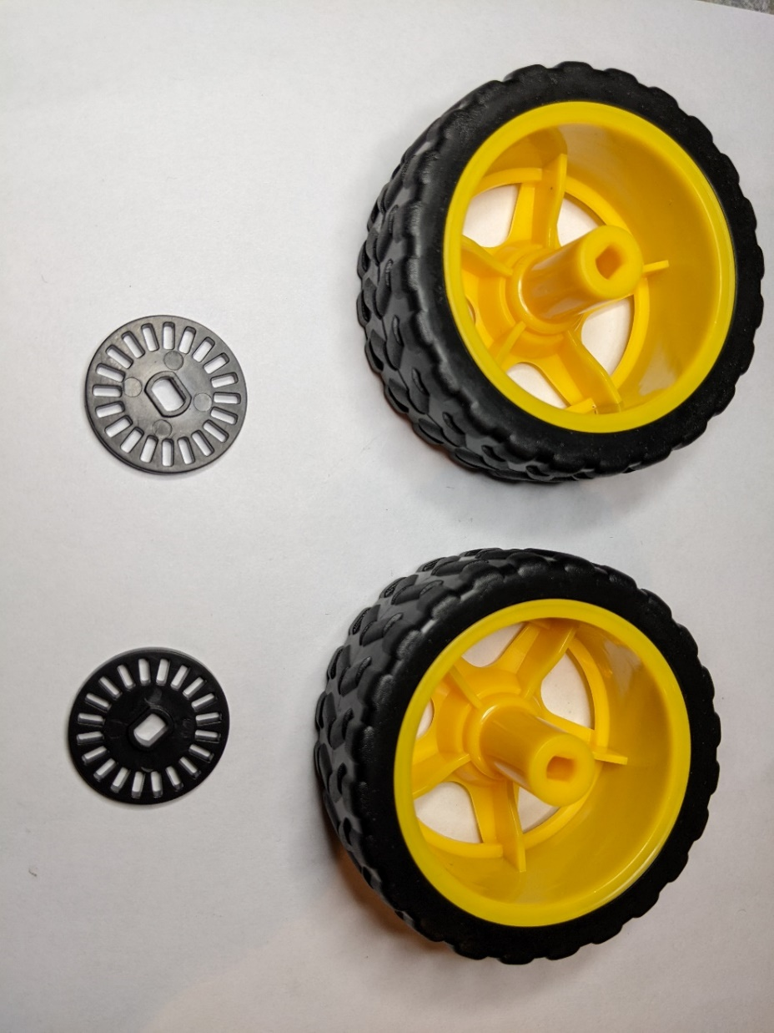 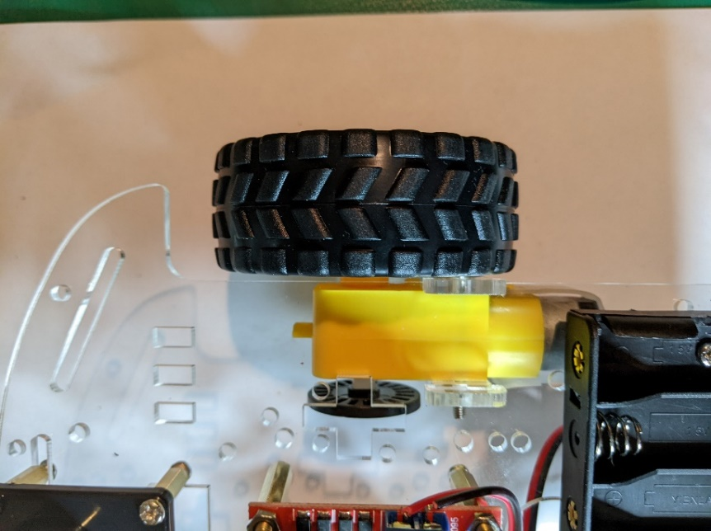

1. Insert the 2 optical sensors into the slots above the rotary encoder disks. The 3 pins should point towards the wider end of the base plate. Attach with one narrow diameter bolt and one small nut for each sensor.

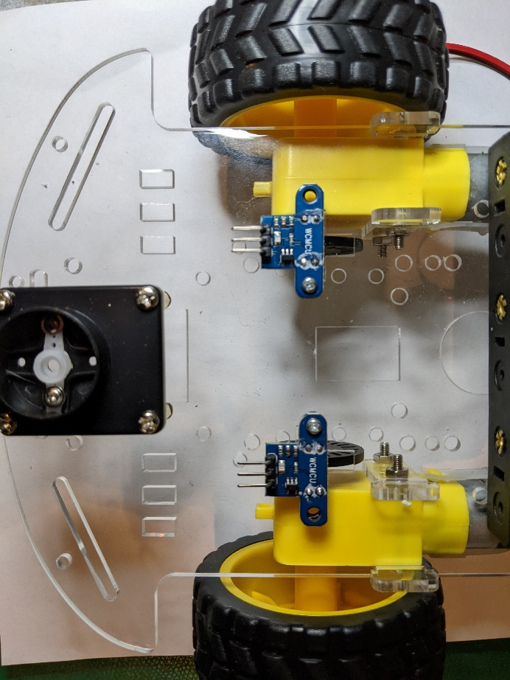

1. Identify the caster wheel, short 12mm standoffs (4), and short bolts (8).

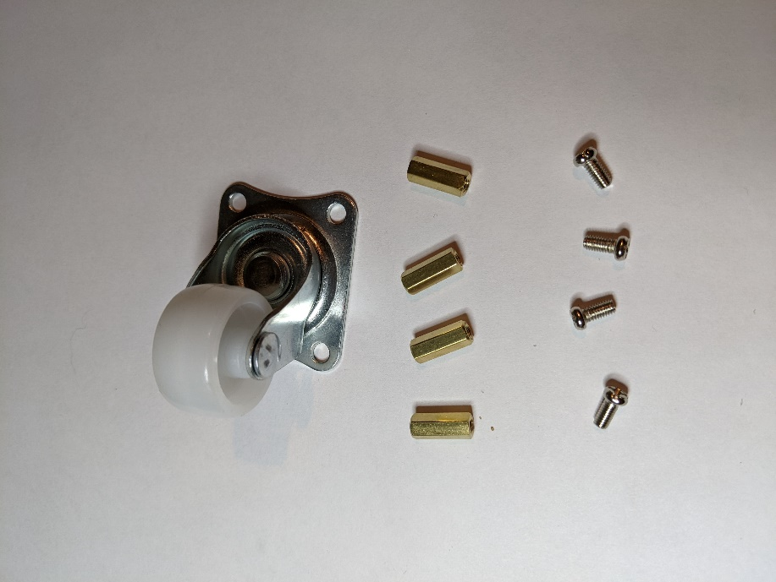

1. Attach the standoffs to the base of the caster wheel and then attach to the bottom of the base plate on the narrow end.

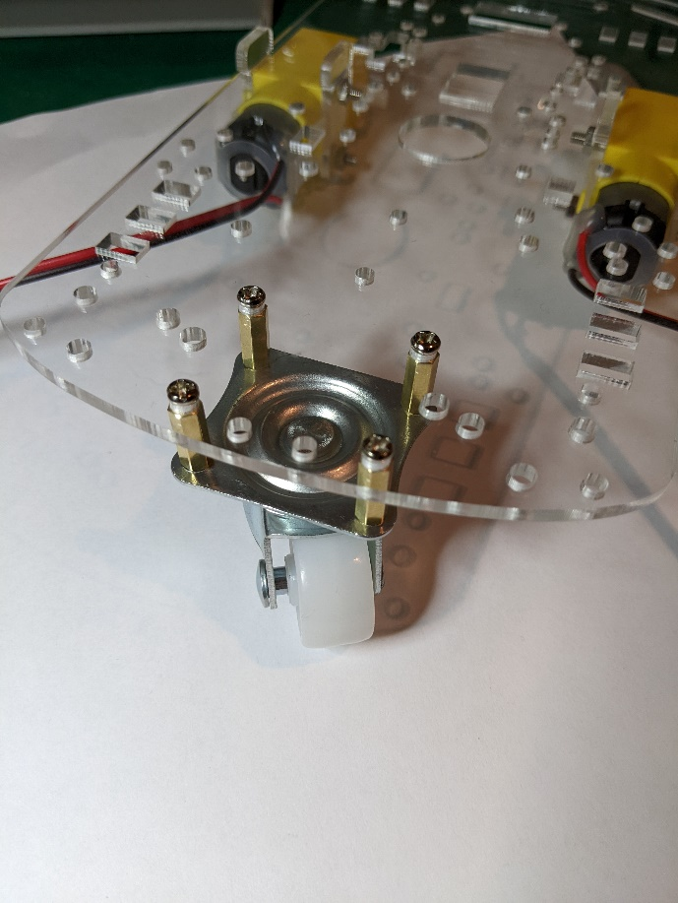

1. Identify the motor driver, medium 20mm standoffs (3), and nuts (3).
2. Attach the standoffs to the motor driver using the nuts. Standoffs are only attached to three of the four holes as shown.

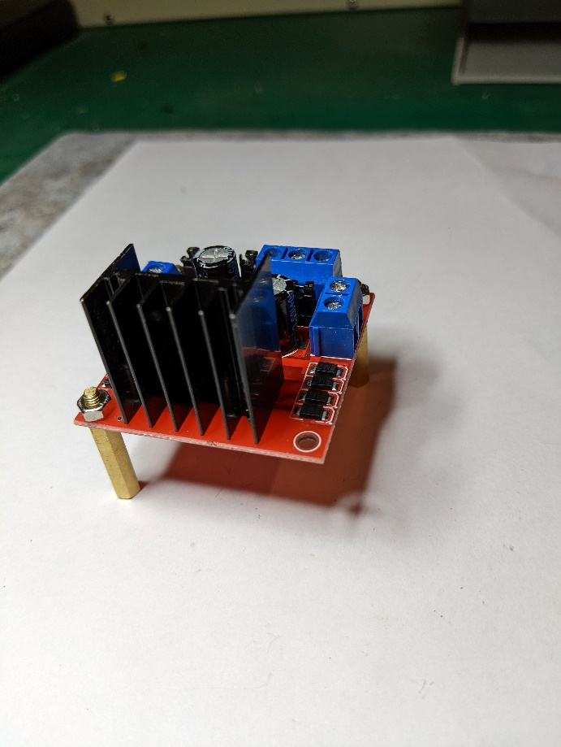 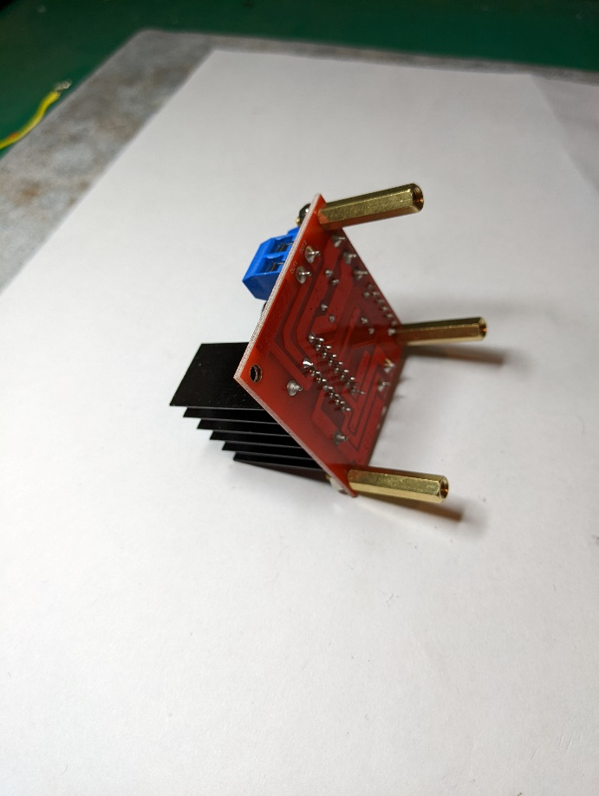

1. Identify the servo motor base, short 12mm standoffs (4) and short bolts (4).
2. Attach the standoffs to the servo motor base using the bolts.
   1. The holes are smaller than the bolts so will need to use a drill or a screwdriver to open them up before inserting the bolts.

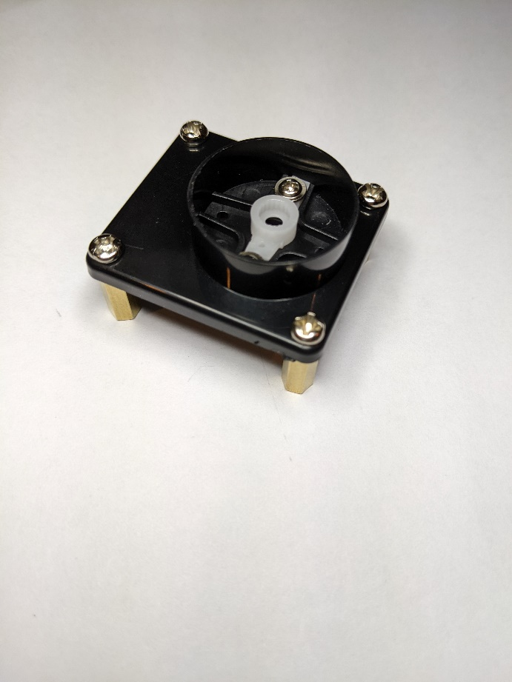

1. Attach the motor driver and servo motor base to the top of the base plate using short bolts (6).
   1. The motor driver only has 2 bolts – one standoff does not have a corresponding hole on the base plate as shown below. Note that the motor driver is off-center.
   2. Two of the bolts for the servo motor base plate go into a slot as shown below.

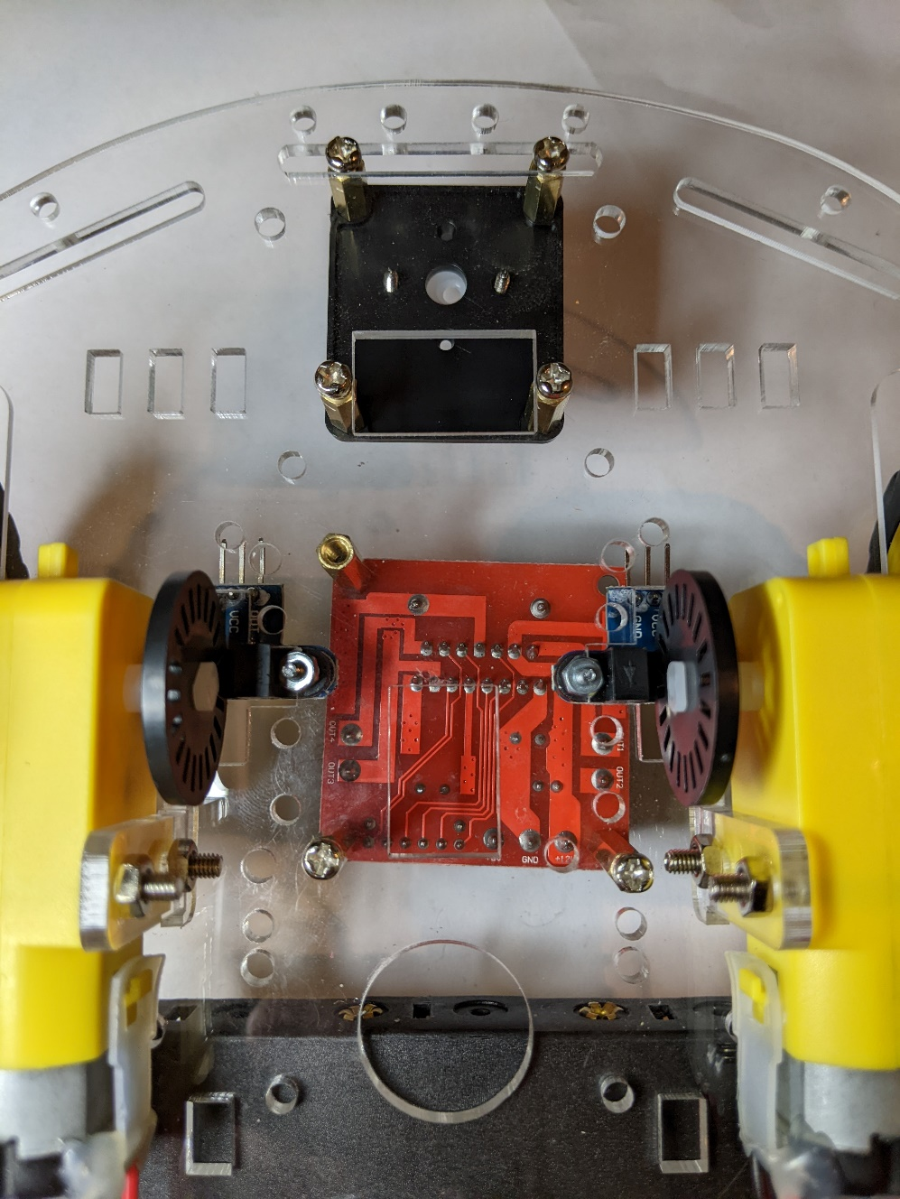

1. Attach a wheel to each motor.

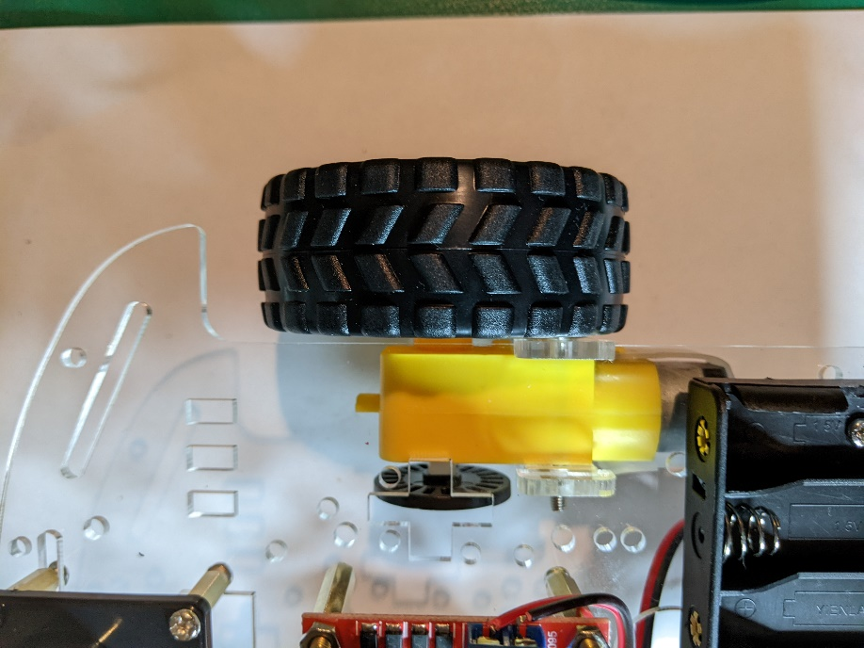

1. Identify servo motor, brackets (2), ultrasonic sensor, and zip ties (2).

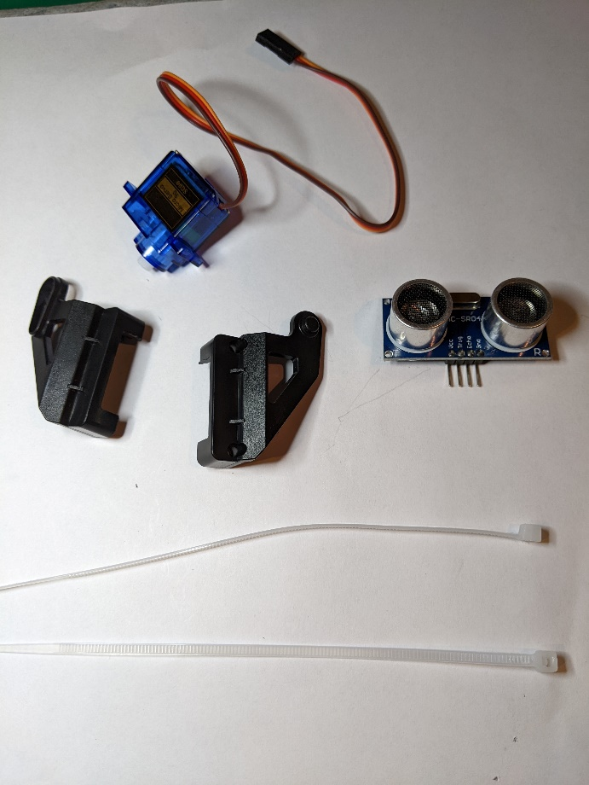

1. Attach the brackets to the servo motor. Use 2 screws to secure the two brackets together.

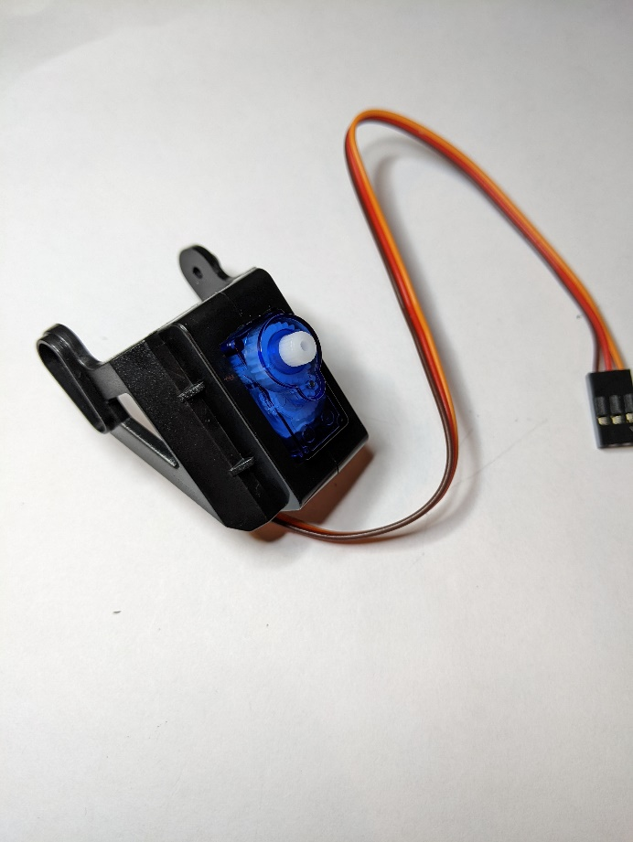

1. Place the ultrasonic sensor along the front of the brackets and secure with zip ties.
   1. The 4 pins on the ultrasonic sensor come out on the same side as the wires from the servo motor.

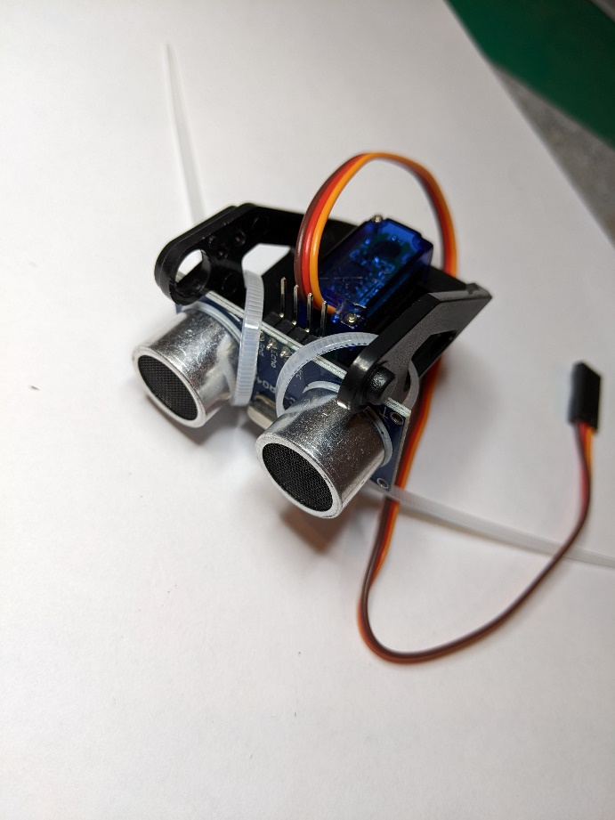

1. Attach the white shaft from the servo motor into the servo motor base.
   1. Gently rotate the ultrasonic sensor assembly to find the range of travel. Remove and reinsert so that the sensor points forward at the middle of the range of travel.

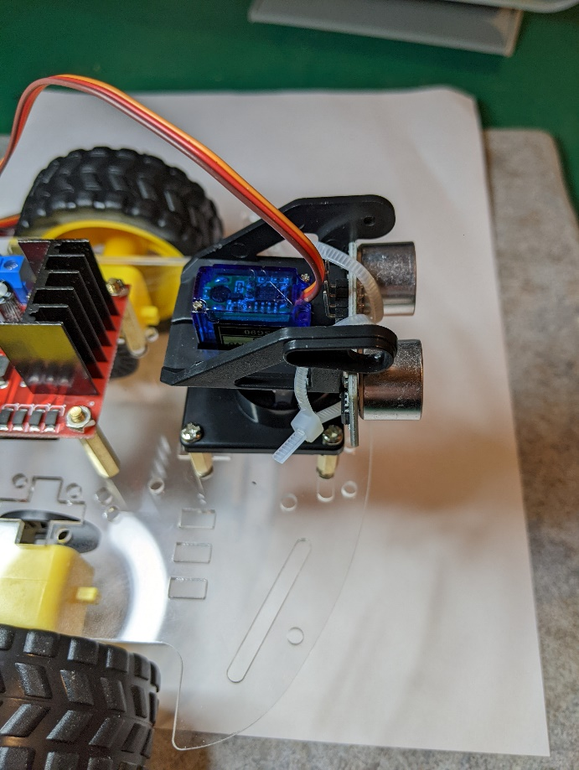

1. Connect the battery holder to the top of the base plate on the narrow end using 2 bolts and 2 nuts.
   1. The holes used are slightly off-center
   2. The wires should be on the side closer to the caster wheel.
   3. The image below shows the battery holder from the bottom side of the base plate.

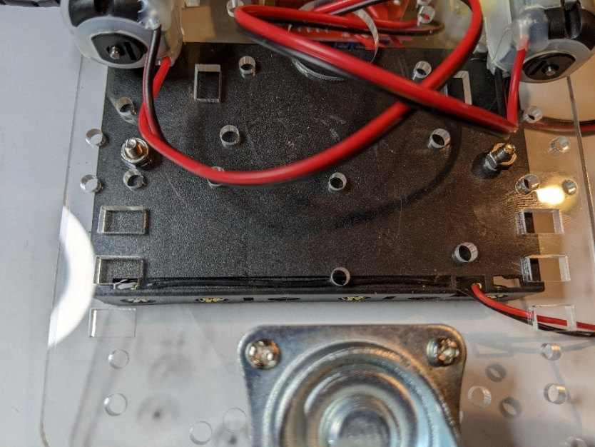

1. Insert the rocker switch through the hole from the bottom of the base plate. It will snap into place. The wires should point towards the battery holder.

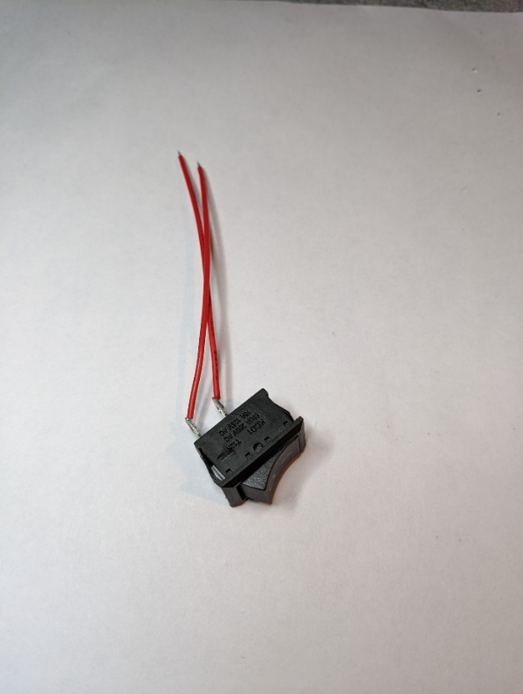 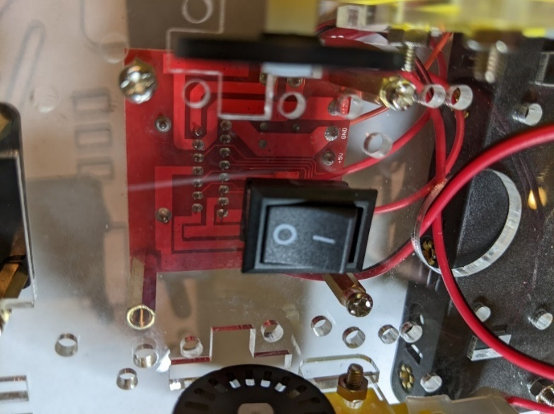

1. Feed the motor wires through the large round hole and connect to the terminal blocks on the motor driver.
   1. Loosen the screws on the terminal blocks before inserting the wires.
   2. You may need to strip the wires to have slightly more wire exposed to fit fully into the terminal blocks.
   3. Tighten the screws on the terminal blocks to secure the wires.

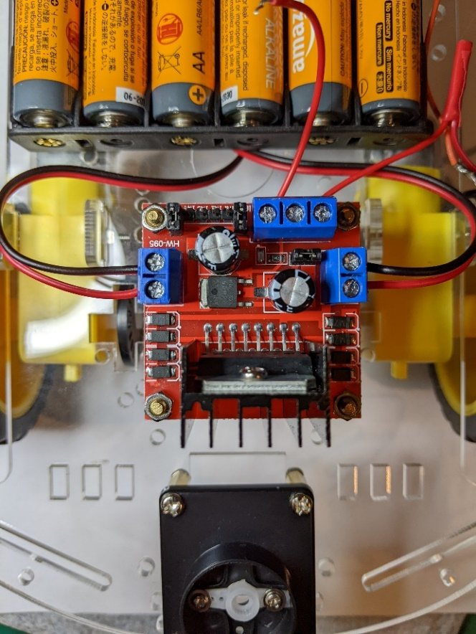

1. Cut the red wire that comes out of the battery holder at the end near the barrel plug. Strip this wire and solder it to one of the wires from the rocker switch – it doesn't matter which one.
2. Solder a short red wire (~5cm) to the long red wire that comes from the barrel plug.
3. Solder a short green wire (~5cm) to the long black wire that comes from the barrel plug.
4. Cover the 3 solder joints with electrical tape to prevent accidental shorts.
5. Connect the wire from the other side of the rocker switch and the long red wire from the barrel plug to the 12V terminal on the motor driver.
   1. If you have trouble getting both wires to connect solidly, you may want to solder them together before inserting them into the terminal block.
6. Connect the green wire from the barrel plug to the GND terminal on the motor driver. The GND terminal on the motor driver is in the middle.

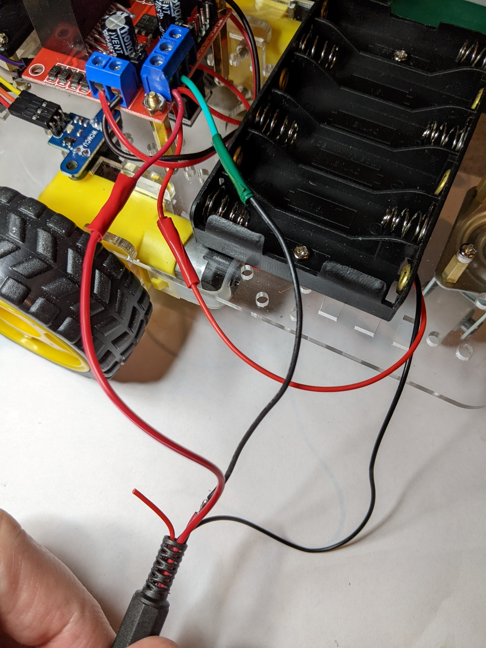

1. Locate the Sensor Shieldv5.0 board.

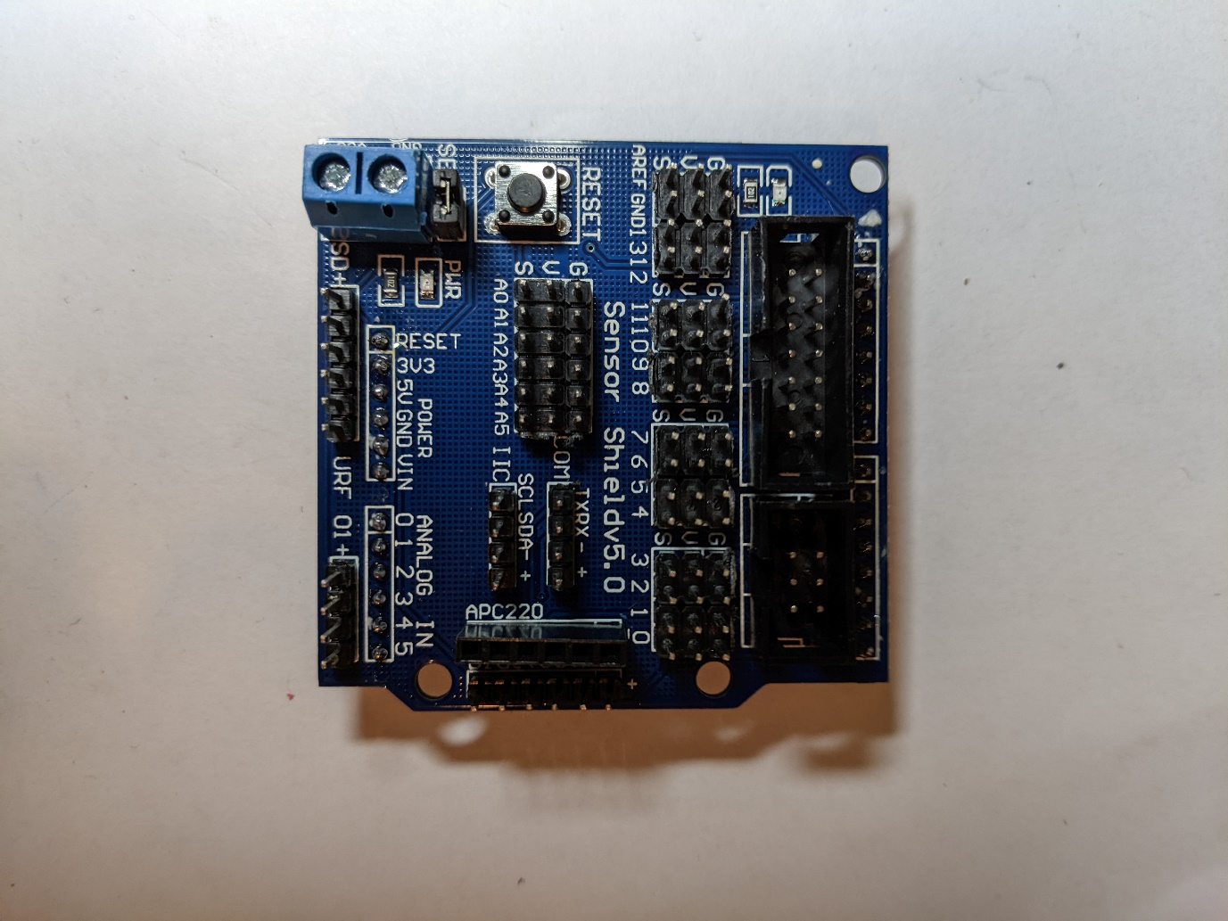

1. Bend the 5V pin on the shield to prevent 5V from being supplied to the "V" terminals on the shield.
   1. This step and the next one are done so that the sensors will be powered by 3.3V instead of 5V. This is necessary because the PSoC operates at 3.3V.

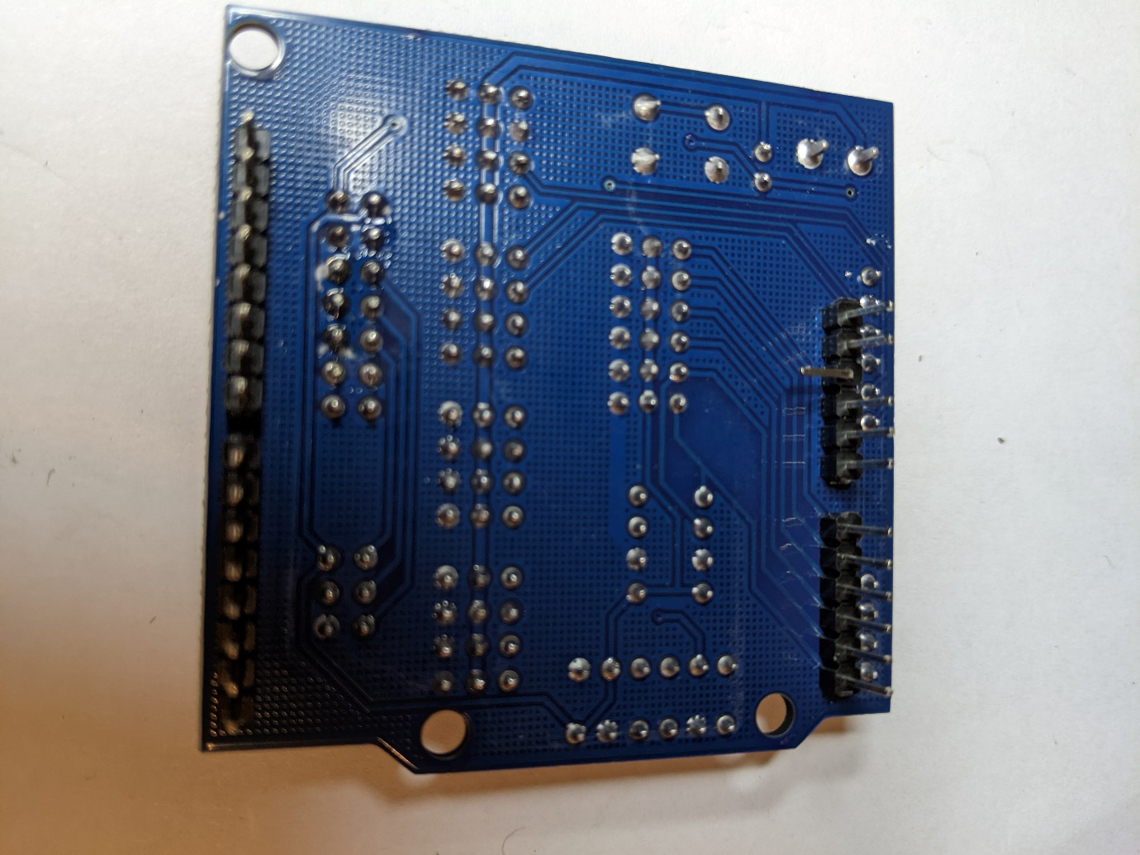

1. Connect a wire from the "3V3" terminal to any of the "V" terminals on the shield. The figure shows it connected to V in the A5 column.

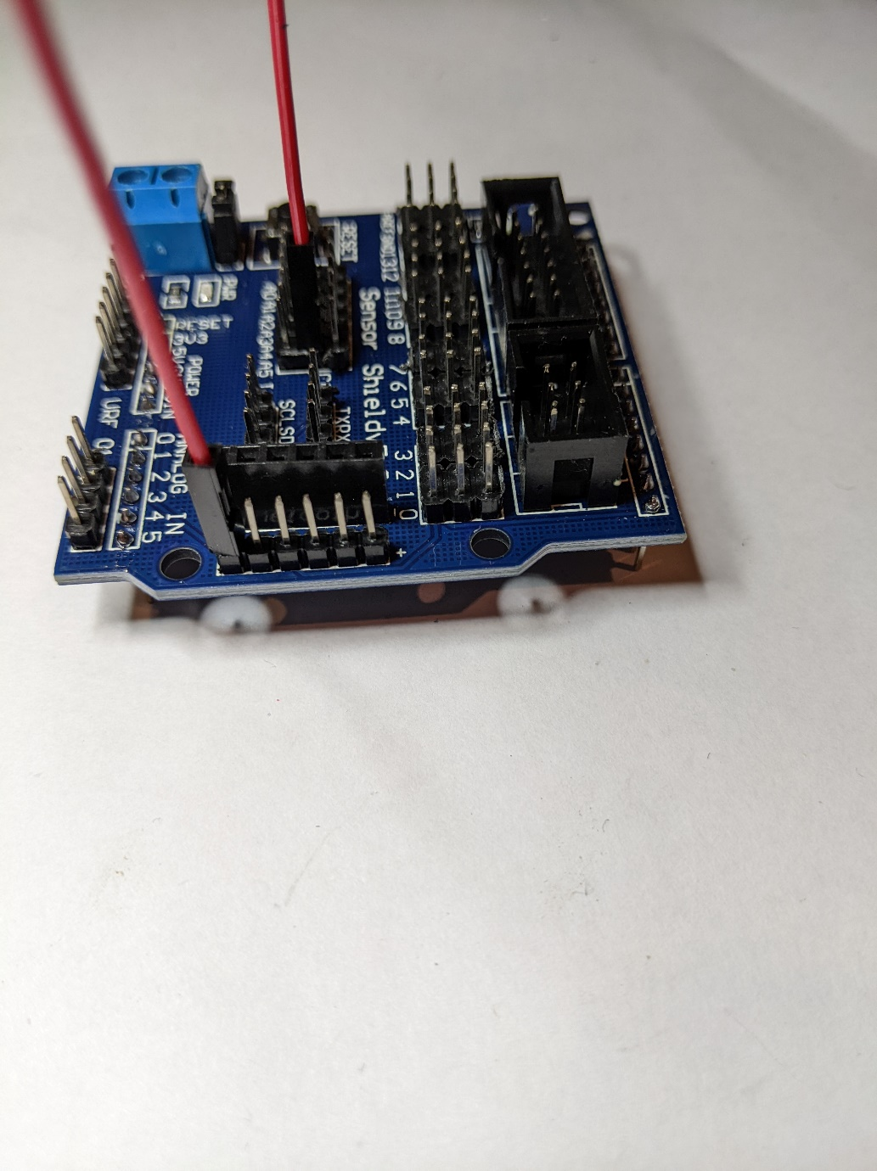 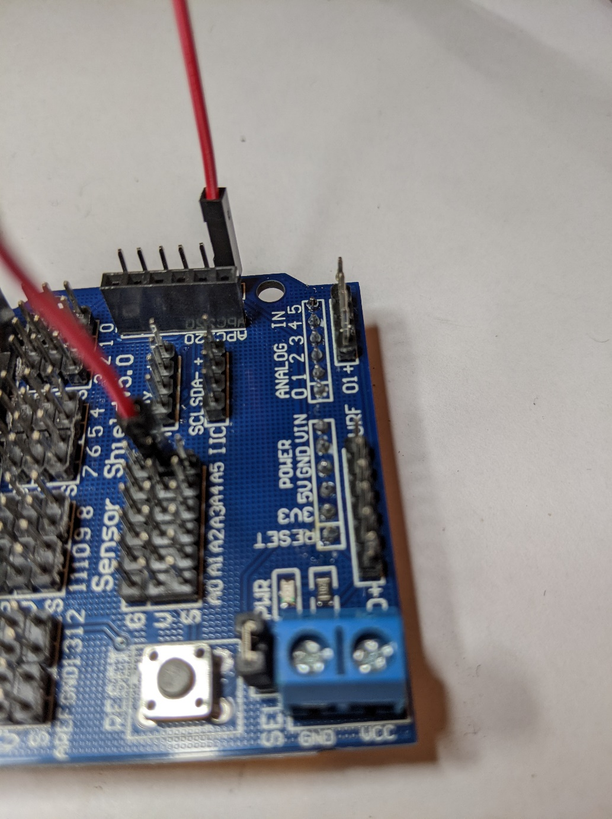

3V3 is left-most pin

1. Insert batteries. Be careful to use the proper polarity.
2. Attach the shield to the PSoC 6 kit. Be careful to line up the shield pins and make sure the 5V pin that you bent earlier does not connect.
3. Attach long 30mm standoffs along the narrow edge of the base plate.

These will be used to hold the PSoC 6 kit in place.

1. Place the PSoC 6 kit over the battery holder with the power connector to the left just behind the standoffs.
2. Connect wires from the shield to the motor driver control pins. The mapping is:

|  |  |
| --- | --- |
| **Shield Pin** | **Motor Driver Pin** |
| Signal D8 | IN4 |
| Signal D9 | IN3 |
| Signal D10 | IN2 |
| Signal D11 | IN1 |

1. Connect wires from the shield to the ultrasonic sensor. The mapping is:

|  |  |
| --- | --- |
| **Shield Pin** | **Ultrasonic Sensor Pin** |
| Signal D13 | Trig |
| Signal D12 | Echo |
| V (use any V pin) | Vcc |
| G (use any G pin) | Gnd |

1. Connect wires to the shield from servo motor. The mapping is:

|  |  |
| --- | --- |
| **Shield Pin** | **Servo Motor Wire** |
| Signal A4 | Orange |
| V A4 | Red |
| G A4 | Brown |

1. Connect wires from the shield to the optical sensors. The mapping is:

|  |  |
| --- | --- |
| **Shield Pin** | **Left Optical Sensor Pin** |
| Signal D7 | OUT |
| V D7 | VCC |
| G D7 | GND |

|  |  |
| --- | --- |
| **Shield Pin** | **Right Optical Sensor Pin** |
| Signal D2 | OUT |
| V D2 | VCC |
| G D2 | GND |

1. Once the wiring is complete, the shield should look like this:

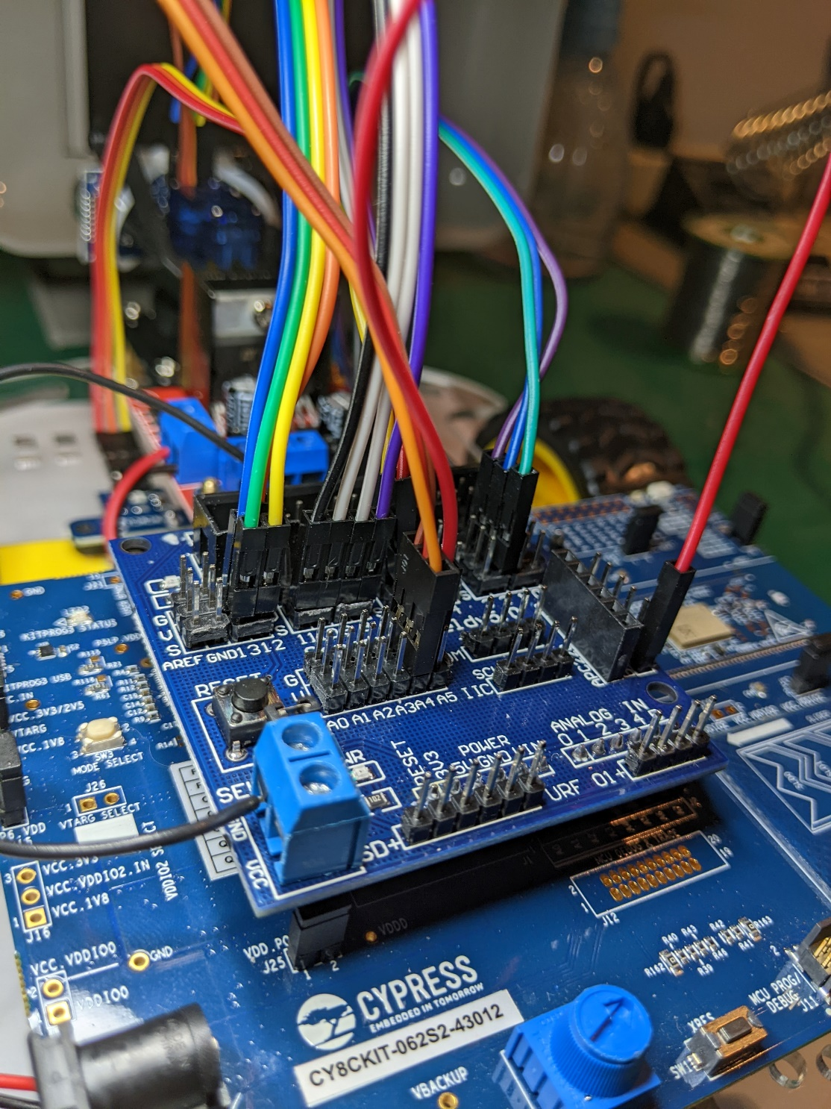

1. Finally, here is what the completed car looks like:

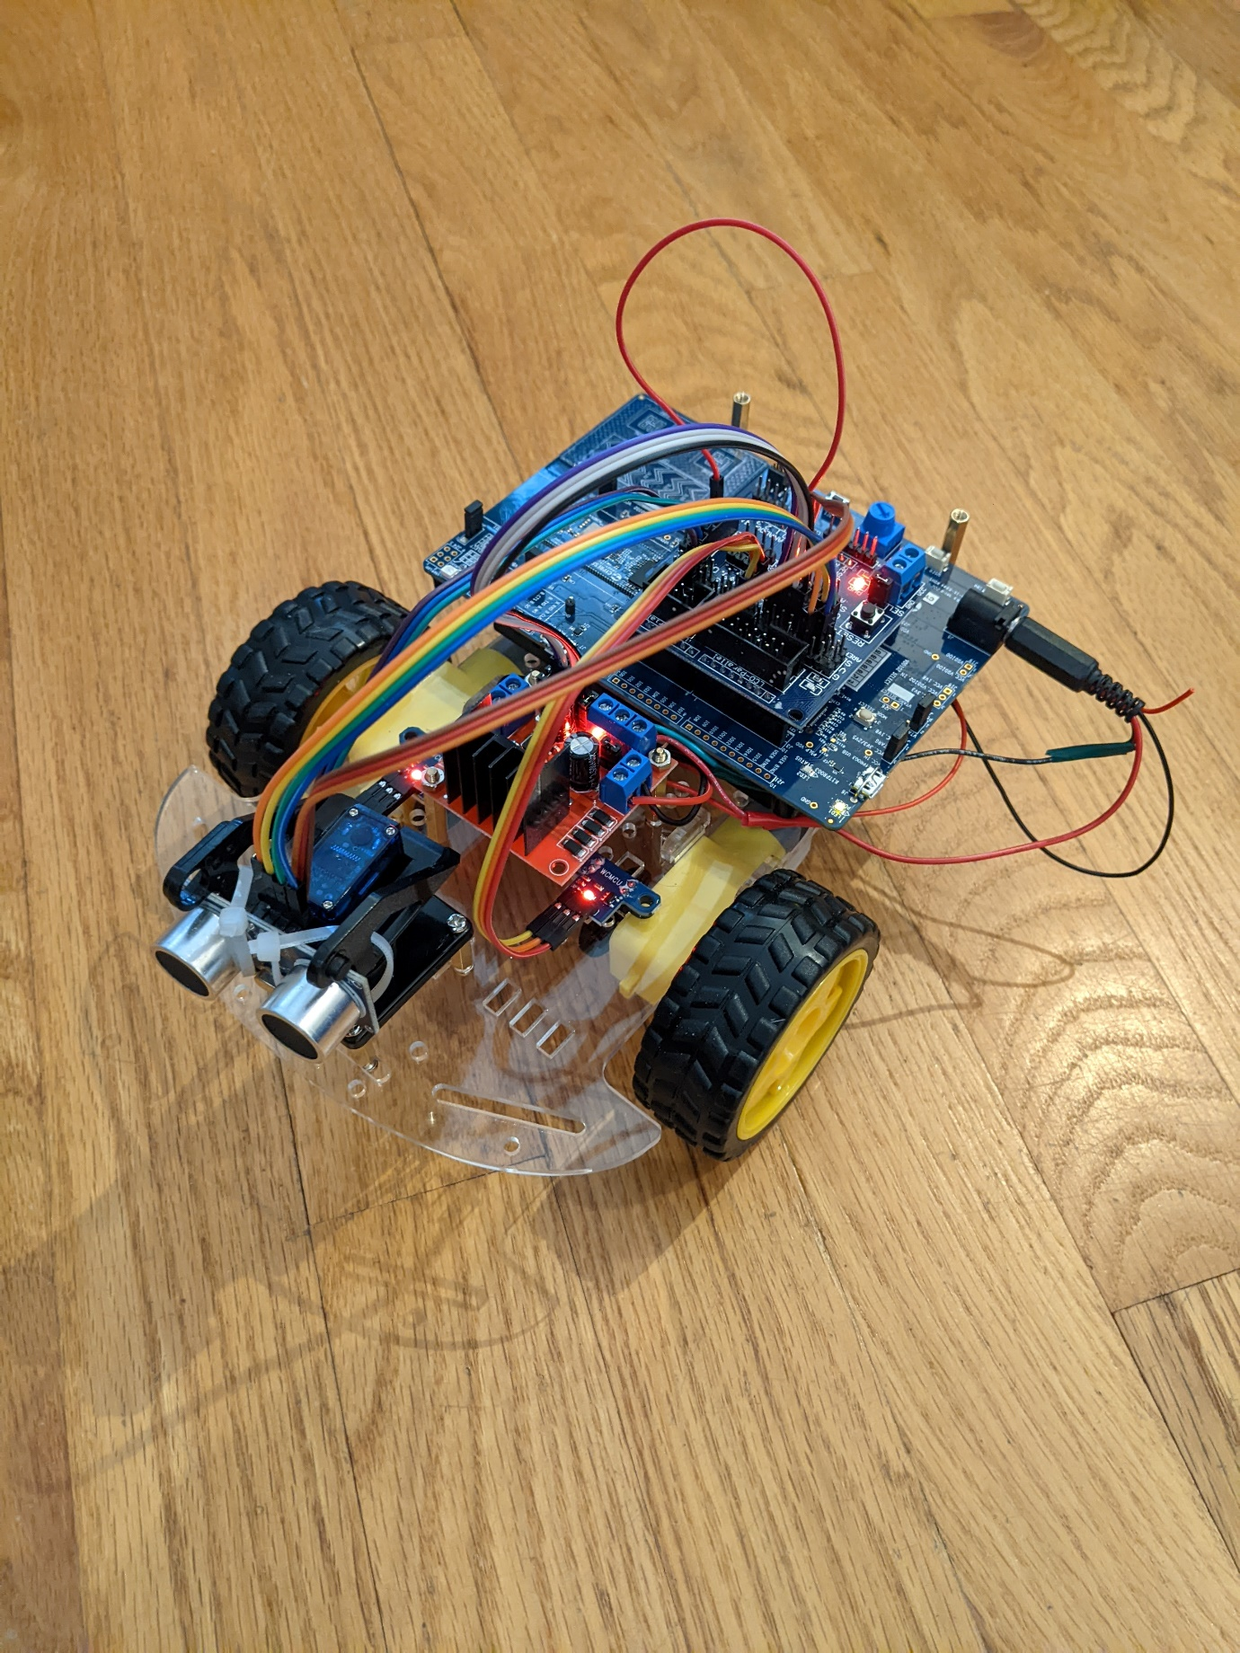

# Testing

## Test wheel motors and servo motor (for ultrasonic sensor angle)

1. Make sure the rocker switch is in the off position.
   1. This will prevent the motors from turning inadvertently before you are ready. It will also prevent 2 different sources of power from being connected to the PSoC 6 kit – the barrel connector and the USB cable. It isn't strictly necessary since the PSoC 6 kit will be powered by whichever voltage is higher. However, it is best to only provide one power source at a time to eliminate the possibility of transient voltages to the kit.
2. Connect a USB cable to the PSoC 6 kit and program it with the test firmware.
3. Disconnect the USB cable from the PSoC 6 kit.
4. Place the kit in an open area on the floor.
5. Turn the rocker switch to the ON position if it isn't already.
   1. You should see a red LED glowing on both the shield board and the motor driver board. If not, check your connections.
6. Press and release user button 2. After a short delay, the kit will:
   1. Move forward.
   2. Move backward.
   3. Rotate counterclockwise.
   4. Rotate clockwise.
   5. Turn the servo all the way to the left, all the way to the right, and then center it.
7. Adjust ultrasonic sensor if necessary by lifting the servo out of the base, turning it until the sensor points forward, pressing it back into the base.
8. If you want to run the test again, reset the kit by toggling the rocker switch or by pressing the reset button and then press user button 2.

## Test ultrasonic and optical sensors

1. Turn off the rocker switch.
2. Connect a USB cable to the PSoC 6 kit.
3. Open a UART terminal window and connect to the kit.
4. Press user button 2.
5. The kit will run through the driving tests, but since the rocker switch is turned off, the wheels will not turn.
6. When the driving tests are done, press user button 2 again.
7. Distance measurements will be continuously displayed by the UART.
   1. Move your hand in front of the ultrasonic sensor to verify proper operation. You should see smaller count values as you move your hand closer.
8. Manually turn each wheel to see the Left and Right counts from the optical sensors increase.